Chapter 1
Self-Review Exercises 1.1
Fill in the blanks in each of the following statements:
a) Computers process data under the control of sets of instructions called ___________ . Ans: Computer Programs
b) The key logical units of the computer are the ______,_______,________ ,_____ ,______ and ______. Ans: Input unit, output unit and processing unit
c) The three types of languages they are_______ , _________and ________. Ans: Machine language, assembly language and high-level language
d) The programs that translate high-level language programs into machine language are called ____________ . Ans: Compliers
e) ________is an operating system for mobile devices based on the Linux kernel and Java. Ans: Android
f) _______ software is generally feature complete, (supposedly) bug free and ready for use by the community. Ans: Release software
g) The Wii Remote, as well as many smartphones, use a(n) ________which allows the device to respond to motion.

1.2 Fill in the blanks in each of the following sentences about the Java environment:
a) The _______ command from the JDK executes a Java application. Ans: java
b) The _______ command from the JDK compiles a Java program. Ans: javc
c) A Java source code file must end with the _______ file extension. Ans: .java
d) When a Java program is compiled, the file produced by the compiler ends with the ________ file extension. Ans: .class
e) The file produced by the Java compiler contains _________ that are executed by the Java Virtual Machine. Ans: bytecode

1.3 Fill in the blanks in each of the following statements

a) Objects enable the design practice of_______ —although they may know how to communicate with one another across well-defined interfaces, they normally are not allowed to know how other objects are implemented. Ans: Encapsulation
b) Java programmers concentrate on creating _____ , which contain fields and the set of methods that manipulate those fields and provide services to clients. Ans: Classes
c) The process of analyzing and designing a system from an object-oriented point of view is called ________. Ans: Object-oriented design
d) A new class of objects can be created conveniently by _________ —the new class (called the subclass) starts with the characteristics of an existing class (called the superclass), possibly customizing them and adding unique characteristics of its own. Ans: Inheritance
e) ________ is a graphical language that allows people who design software systems to use an industry-standard notation to represent them. Ans: Unified Modeling Language(UML)
f) The size, shape, color and weight of an object are considered_______ of the object’s class. Ans: Attributes

Exercises 1.4 Fill in the blanks in each of the following statements:
a) The logical unit that receives information from outside the computer for use by the computer is the _______ . Ans: Input unit
b) The process of instructing the computer to solve a problem is called _____ . ans: Programming
c) ______ is a type of computer language that uses English-like abbreviations for machine-language instructions. Ans: Assembly language
d) ________ is a logical unit that sends information which has already been processed by the computer to various devices so that it may be used outside the computer. Ans: Output language
e) ________and ______ are logical units of the computer that retain information. Ans: Memory unit and Storage unit
f) __________ is a logical unit of the computer that performs calculations. Ans: Arithmetic Logic Unit(ALU)
g) ________ is a logical unit of the computer that makes logical decisions. Ans: Arithmetic Logic Unit (ALU) (same unit handles both arithmetic and logic operations)
h) __________ languages are most convenient to the programmer for writing programs quickly and easily. Ans: High level languages
i) The only language a computer can directly understand is that computer’s_________. Ans: Machine language
j) _________ is a logical unit of the computer that coordinates the activities of all the other logical units. Ans: Control unit

1.5 Fill in the blanks in each of the following statements:
a) The _________ programming language is now used to develop large-scale enterprise applications, to enhance the functionality of web servers, to provide applications for consumer devices and for many other purposes. Ans: Java
b) _________ initially became widely known as the development language of the UNIX operating system. Ans: C
c) The ________ ensures that messages, consisting of sequentially numbered pieces called bytes, were properly routed from sender to receiver, arrived intact and were assembled in the correct order. Ans: Transmission Control Protocol (TCP)
d) The ____________ programming language was developed by Bjarne Stroustrup in the early 1980s at Bell Laboratories. Ans: c++
1.6 Fill in the blanks in each of the following statements:
a) Java programs normally go through five phases— ______, _______ ,_________ , _________ and _________ . ans: Edit, Compile, Load, Verify and Execute
b) A(n)__________ provides many tools that support the software development process, such as editors for writing and editing programs, debuggers for locating logic errors in programs, and many other features. Ans: Integrated Development Environment (IDE)
c) The command java invokes the __________, which executes Java programs. Ans: Java Virtual Machine(JVM)
d) A(n) ________ is a software application that simulates a computer, but hides the underlying operating system and hardware from the programs that interact with it. Ans: Virtual Machine
e) The _________ takes the .class files containing the program’s bytecodes and transfers them to primary memory. Ans: Class Loader
f) The __________ examines bytecodes to ensure that they’re valid. Ans: Bytecode Verifier

1.7 Explain the two compilation phases of Java programs.
ANS:
- Compilation Phase – The source code (.java file) is compiled by the Java compiler (javac) into bytecode (.class file), which is platform-independent.
- Execution Phase – The JVM (Java Virtual Machine) reads the bytecode and interprets/executes it on the specific machine.

1.8 One of the world’s most common objects is a wrist watch. Discuss how each of the following terms and concepts applies to the notion of a watch: object, attributes, behaviors, class, inheritance (consider, for example, an alarm clock), modeling, messages, encapsulation, interface and information hiding.
Ans:
- Object – A specific wrist watch, e.g., your watch.
- Attributes – Color, brand, time, battery level.
- Behaviors – Display time, tick, set alarm.
- Class – The general blueprint/design called "Watch."
- Inheritance – An alarm clock inherits all watch features and adds alarm functionality.
- Modeling – Representing a real watch as a class in a program.
- Messages – Calling methods like setAlarm() or showTime().
- Encapsulation – The internal mechanism is hidden inside the watch casing.
- Interface – The buttons/crown used to interact with the watch.
- Information Hiding – You don't need to know how the gears work to use the watch.

Making a Difference
1.9 (Test-Drive: Carbon Footprint Calculator)
Some scientists believe that carbon emissions, especially from the burning of fossil fuels, contribute significantly to global warming and that this can be combatted if individuals take steps to limit their use of carbon-based fuels. Organizations and individuals are increasingly concerned about their “carbon footprints.” Websites such as TerraPass http://www.terrapass.com/carbon-footprint-calculator/ and Carbon Footprint http://www.carbonfootprint.com/calculator.aspx provide carbon-footprint calculators. Test-drive these calculators to determine your carbon footprint. Exercises in later chapters will ask you to program your own carbon-footprint calculator. To prepare for this, use the web to research the formulas for calculating carbon footprints.
ANS:
I visited the TerraPass Carbon Footprint Calculator and entered my data:
- Car travel: ___ miles/year
- Flights: ___ per year
- Home energy: ___ kWh/month
My estimated carbon footprint is ___ tonnes of CO₂ per year. To reduce this, I could: use public transport, reduce electricity use, and fly less.

1.10 (Test-Drive: Body Mass Index Calculator)
Obesity causes significant increases in illnesses such as diabetes and heart disease. To determine whether a person is overweight or obese, you can use a measure called the body mass index (BMI). The United States Department of Health and Human Services provides a BMI calculator at http://www.nhlbi.nih.gov/guidelines/obesity/BMI/ bmicalc.htm. Use it to calculate your own BMI. A forthcoming exercise will ask you to program your own BMI calculator. To prepare for this, use the web to research the formulas for calculating BMI.
Ans:
I visited the BMI Calculator and entered my details:
- Height: 6 feet 6.5 inches
- Weight: 120 pounds
- My BMI = 13.7
According to the BMI chart, a BMI of 13.7 falls below 18.5, which places me in the Underweight category. To reach a healthy weight, I would need to weigh at least 161.8 lbs for my height.
The BMI formula calculates body fat based on height and weight, and is used by health professionals to determine whether a person is underweight, healthy, overweight, or obese.
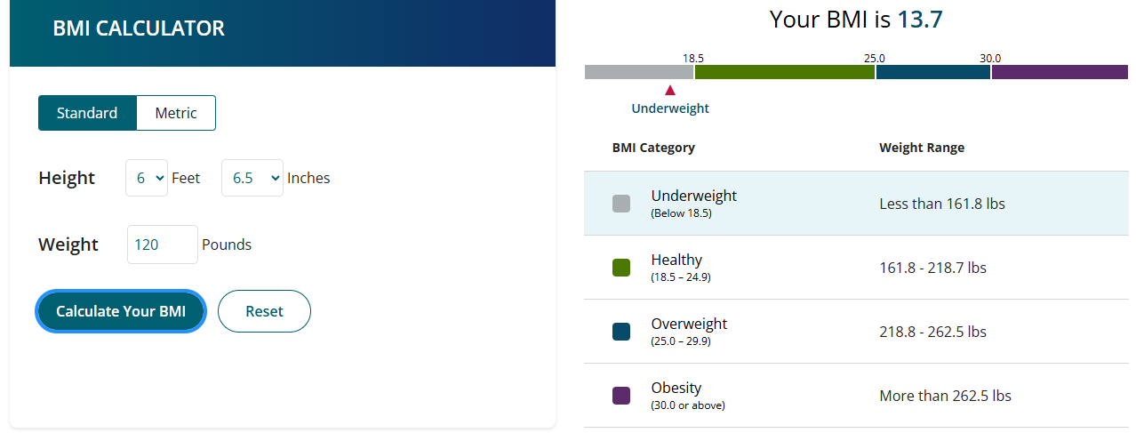

1.11 (Attributes of Hybrid Vehicles)
Hybrid vehicles are becoming increasingly popular, because they often get much better mileage than purely gasoline-powered vehicles. Browse the web and study the features of four or five of today’s popular hybrid cars, then list as many of their hybrid-related attributes as you can. Some common attributes include city-miles-per-gallon and highway-miles-per-gallon. Also list the attributes of the batteries (type, weight, etc.).
Ans:
Attribute | Toyota Prius | Honda Insight | Ford Fusion Hybrid | Hyundai Ioniq
City MPG | 54 | 55 | 43 | 57
Highway MPG | 50 | 49 | 41 | 59
Battery Type | Nickel-metal hydride | Lithium-ion | Lithium-ion | Lithium-ion
Battery Weight | ~53kg | ~45kg | ~65kg | ~40kg
Engine | 1.8L+Electric | 1.5L+Electric | 2.0L+Electric | 1.6L + Electric

1.12 (Gender Neutrality)
Many people want to eliminate sexism in all forms of communication. You’ve been asked to create a program that can process a paragraph of text and replace gender-specific words with gender-neutral ones. Assuming that you’ve been given a list of gender-specific words and their gender-neutral replacements (e.g., replace both “wife” and “husband” with “spouse,” “man” and “woman” with “person,” “daughter” and “son” with “child”), explain the procedure you’d use to read through a paragraph of text and manually perform these replacements. How might your procedure generate a strange term like “woperchild?” You’ll soon learn that a more formal term for “procedure” is “algorithm,” and that an algorithm specifies the steps to be performed and the order in which to perform them. We’ll show how to develop algorithms then convert them to Java programs which can be run on computers.
Ans:
Procedure:
To replace gender-specific words with gender-neutral ones, I would follow these steps:
- Obtain a paragraph of text and a list of gender-specific words with their gender-neutral replacements.
- Read through the paragraph word by word from beginning to end.
- For each word, check if it exists in the gender-specific word list.
- If a match is found, replace it with the corresponding gender-neutral word.
- Continue until the entire paragraph has been processed.
How "woperchild" is Generated:
This strange term is generated due to the order of replacements. For example:
- The word "woman" is first replaced with "woperson" (replacing "man" with "person")
- Then "man" inside "woperson" is replaced again giving "woperchild" (replacing "son" with "child")

